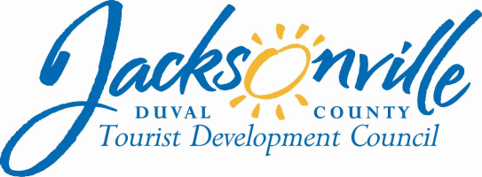
OFFICE OF THE CITY COUNCIL

Tourist Development Council
OFFICE: (904) 255-5505 |  | 117 West Duval Street, Suite 260
FAX: (904) 255-5506 |  | 2nd Floor, City Hall
E-MAIL: tdc@coj.net |  | Jacksonville, FL 32202

A G E N D A

TOURIST DEVELOPMENT COUNCIL MEETING
Council President Aaron L. Bowman, TDC Chairman
Thursday, May 9, 2019
1:30 P.M.
117 West Duval Street
City Hall, First Floor
Lynwood Roberts Room

I. Call to Order
- Roll Call
II. Introduction – Council President Aaron Bowman, TDC Chairman
III. Public Comments (Voting Items)
IV. Approval of Minutes
- TDC Meeting –April 11, 2019
Action Item: ____
V. TDC Financial Report Kim Taylor, Assistant Council Auditor
VI. Establish Work Group for Strategic Planning Process
Action Item: ____
VII. Visit Jacksonville Year 3 Plans
Action Item: _______
VIII. FFCG New Contract
Action Item: _______
IX. Grant Applications Review
- UNF Track and Field
Action Item: _______
- Airstream - Motocross
Action Item: _______
- JaxSports – Florida State vs. Boise
Action Item: _______
X. Mobile Visitors Center
Action Item: _______
XI. Visit Jacksonville Travel Plan Changes
Action Item: _______
XII. CVB Grant Approvals
Action Item: _______
XIII. Visit Jacksonville Quarterly Updates

XIV. Tuck’N Presentation/Demo

XV. Other Business
XVI. Public Comments
XVII. Closing Comments
- Next Meeting – June 13, 2019
XVIII. Adjourn
***Other Items may be added or deferred at discretion of the Chair. ***

